

Project Report, Fall 2021-22

|  |  |  |  |
| --- | --- | --- | --- |
| Course | Introduction to Database [H] | Group | NOT GIVEN |

**Group Members:**

|  |  |  |
| --- | --- | --- |
| Student ID | Name | Contribution |
| 21-44681-1 | SABITUL IQRAM | Introduction and Scenario description |
| 21-44664-1 | CHOWDHURY, SAFWAN UDDIN | ER Diagram, normalization |
| 21-44634-1 | SHIKDAR, JAHIDUL ISLAM | Table creation Data insertion, |
| 21-44577-1 | UPOL,MD.DAUD HOSSAIN | Queries and conclusion |

**Title:**

|  |
| --- |
| PRISON MANAGEMENT SYSTEM |

**SUBMITTED TO**

**Dr. S.M. HASAN Mahmud**

**LECTURER**

**AMERICAN INTERNATIONAL UNIVERSITY BANGLADESH**

**TABLE OF CONTENTS**

**Topics page**

1. Title page and group info 01
2. Table of content 02
3. Introduction and Scenario description 03
4. ER Diagram 04
5. Normalization 05
6. Table creation 06-12
7. Data insertion 13-21
8. Queries 22-34
9. Conclusion 35

**INTRODUCTION:**

The project is about prison management system. This system is made to keep record of all the information of a prison. Online database project is much better than paper records. Paper record can be lost and take too much time to search for a particular information and has no backup. User can access prisoner, visitor, and jailor’s information very easily with the help of the prison management system.

**SCENARIO DESCRIPTION:**

In a prison management system, a jailor can permit many visitors. A visitor can be permitted by a jailor. A jailor is identified by jailor id (J_ID), Jailor age (J_AGE) and jailor name (J_NAME) where jailor id (J_ID) is “Primary key”. A jailor becomes visitors and visit prisoner. System stores visitor’s name (V_NAME), visitor’s gender (V_GENDER), visitor’s id (V_ID) here (V_ID) is a “Primary key”, visitor’s number (V_PHONE NUMBER), visitor’s NID number(V_NID), relation with prisoner (RELATION), prisoner ID (P_ID) here (P_ID) is a “Foreign key” and jailor ID (J_ID) here jailor ID (J_ID) is a “Foreign key” . A visitor may visit many prisoners. A prisoner can be visited by many visitors. A prisoner is identified by the prisoner’s name (P_NAME), prisoner id (P_ID) here (P_ID) is a “Primary key”, prisoner’s gender (GENDER), prisoner’s address (ADDRESS), prisoner’s entry date (ENTRY DATE), prisoner’s face reorganization (FACE RECOGNIZE), prisoner’s date of birth (DOB), prisoner’s age (AGE), prisoner’s eye scan (EYE SCAN), and prisoner’s fingerprint (FINGER PRINT). A prisoner has exactly one cell. A cell may have many prisoners. Cell is identified by cell name (CELL NAME), cell number (CELL NUMBER), cell capacity (CAPACITY) and prisoner’s Id (P_ID) here prisoner’s Id (P_ID) is a “Foreign key”. A prisoner may commit many crimes. A crime can be committed by many prisoners. Crime is identified by crime count (CRIME COUNT), remand (REMAND), date in (DATE IN), crime id (CRIME ID) here crime id (CRIME ID) is a “Primary key”, crime case Id (CASE ID) here crime case Id (CASE ID) is a “Foreign key” and prisoner’s Id (P_ID) here prisoner’s Id (P_ID) is a “Foreign key”. Crime has case and cases are identified by case id (CASE ID) here case Id (CASE ID) is a “Primary key” and case type (CASE TYPE). And there is punishment for every prisoner. A prisoner can be punished. Punishment is identified with high punishment (PMENT_HIGH), low punishment (PMENT_LOW) and punishment name (PMENT_NAME).

**ER DIAGRAM :**

V_GENDER

J_ID

P ID

J_ID

V_NAME

J_NAME

JAILOR

VISITOR

V_PHONE NUMBER

PERMIT

V_ID

V_NID

J_AGE

CASE TYPE

RELATION

CASE ID

BECOMES

VISIT

CASE

FACE RECOGNIZE

DOB

P_NAME

EYE SCAN

FINGER PRINT

P_ID

HAS

PRISONER

HAS

ADDRESS

AGE

GENDER

ENRTY DATE

CELL NUMBER

CELL NAME

CELL

COMMIT

CRIME COUNT

CAPACITY

CRIME

P ID

CASE ID

REMAND

P ID

CRIME ID

DATE IN

PMENT_HIGH

PMENT_NAME

PUNISHMENT

PMENT_LOW

**NORMALIZATION:**

* **JAILOR:** This entity has no transitive dependency and functional dependency. So, it is already in 3NF
* **VISITOR:** VISITOR table has phone number which is multivalued attribute. This can be separated in two by phone number 1 and phone number 2 and make this attribute independent. Other attributes of this table are already independent. So, it is also in 3NF.
* **PRISONER:** This table has no transitive or functional dependencies and therefore it is already in 3NF.
* **CRIME:** All the attribute of this table can be identified uniquely with the primary key.
* **CASE:** Already in 3NF.
* **CELL:** No functional and transitive dependency.
* **PUNISHMENT:** Already in 3NF.

**TABLE CREATION:**

CREATE TABLE JAILOR

(

J_ID NUMBER(15) CONSTRAINT PK_JID PRIMARY KEY,

J_NAME VARCHAR2(30),

J_AGE NUMBER(3)

);

DESC JAILOR;

CREATE TABLE CASE

(

CASE_ID NUMBER(5) CONSTRAINT PK_CASEID PRIMARY KEY,

CASE_TYPE VARCHAR2(30)

);

DESC CASE;

CREATE TABLE PRISONER

(

P_ID NUMBER(15) CONSTRAINT PK_PID PRIMARY KEY,

P_NAME VARCHAR2(30),

DOB DATE,

P_AGE NUMBER(3),

FINGER_PRINT VARCHAR2(5),

FACE_RECOGNIZE VARCHAR2(5),

EYE_SCAN VARCHAR2(5),

ADDRESS VARCHAR2(5),

GENDER VARCHAR2(10),

ENTRY_DATE DATE,

);

ALTER TABLE PRISONER MODIFY

(

ADDRESS VARCHAR2(100)

);

DESC PRISONER;

CREATE TABLE CELL

(

CELL_NUMBER NUMBER(15) CONSTRAINT PK_CELLNUMBER PRIMARY KEY,

CELL_NAME VARCHAR2(30),

CAPACITY NUMBER(3),

P_ID NUMBER(15) CONSTRAINT FK_PID REFERENCES PRISONER

);

DESC CELL;

CREATE TABLE VISITOR

(

V_ID NUMBER(15) CONSTRAINT PK_VID PRIMARY KEY,

V_NAME VARCHAR2(30),

RELATION VARCHAR2(30),

V_GENDER VARCHAR2(10),

V_PHONE_NUMBER NUMBER(15),

V_NID NUMBER(20),

P_ID NUMBER(15) CONSTRAINT FK_VPID REFERENCES PRISONER,

J_ID NUMBER(15) CONSTRAINT FK_VJID REFERENCES JAILOR

);

DESC VISITOR;

CREATE TABLE CRIME

(

CRIME_ID NUMBER(15) CONSTRAINT PK_CRIMEID PRIMARY KEY,

DATE_IN DATE,

REMAND VARCHAR2(5),

CRIME_COUNT NUMBER(5),

CASE_ID NUMBER(5) CONSTRAINT FK_CCASEID REFERENCES CASE,

P_ID NUMBER(15) CONSTRAINT FK_CPID REFERENCES PRISONER

);

DESC CRIME;

CREATE TABLE PUNISHMENT

(

PMENT_NAME VARCHAR2(30),

PMENT_LOW NUMBER(5),

PMENT_HIGH NUMBER(5)

);

DESC PUNISHMENT;

**DATA INSERTION:**

INSERT INTO JAILOR VALUES(101,'SAFWAN CHOWDURY',30);

INSERT INTO JAILOR VALUES(102,'JAHIDUL ISLAM SHIKDAR',26);

INSERT INTO JAILOR VALUES(103,'DAUD HASAN UPOL',31);

INSERT INTO JAILOR VALUES(104,'SABITUL IQRAM',29);

INSERT INTO JAILOR VALUES(105,'HASAN MAHMUD',25);

SELECT * FROM JAILOR;

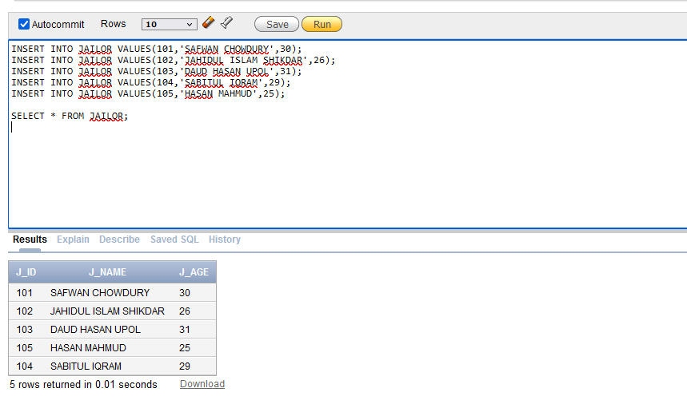

INSERT INTO CASE VALUES(201,'MURDER');

INSERT INTO CASE VALUES(202,'RAPE');

INSERT INTO CASE VALUES(203,'KIDNAPPING');

INSERT INTO CASE VALUES(204,'ARMED ROBBERY');

INSERT INTO CASE VALUES(205,'INSIDER TRADING');

INSERT INTO CASE VALUES(206,'FRAUD');

INSERT INTO CASE VALUES(207,'EXTORTION');

INSERT INTO CASE VALUES(208,'HARASSMENT');

INSERT INTO CASE VALUES(209,'CYBER BULLYING');

INSERT INTO CASE VALUES(210,'THEFT');

SELECT * FROM CASE;

INSERT INTO PRISONER VALUES(1001,'NAHID HASSAN',TO_DATE( '01 Jan 1999', 'DD MON YYYY'),22,'YES','YES','YES','ROAD 2,JOYPARA,DOHAR,DHAKA,BANGLADESH','MALE',TO_DATE( '01 Jan 1999', 'DD MON YYYY'));

UPDATE PRISONER SET ENTRY_DATE = TO_DATE( '19 Jan 2018', 'DD MON YYYY') WHERE P_ID =1001;

INSERT INTO PRISONER VALUES(1002,'ARMAN ARIF',TO_DATE( '26 Jan 1999', 'DD MON YYYY'),22,'YES','YES','YES','ROAD 3,KHILGAON,DHAKA,BANGLADESH','MALE',TO_DATE( '26 Jan 2017', 'DD MON YYYY'));

INSERT INTO PRISONER VALUES(1003,'ALI AHMED',TO_DATE( '26 Jan 1998', 'DD MON YYYY'),23,'YES','YES','YES','ROAD 9,RAMPURA,DHAKA,BANGLADESH','MALE',TO_DATE( '27 OCT 2013', 'DD MON YYYY'));

INSERT INTO PRISONER VALUES(1004,'SAKIB NABI',TO_DATE( '26 JUL 1997', 'DD MON YYYY'),24,'YES','YES','YES','ROAD 7,MOHAMMADPUR,DHAKA,BANGLADESH','MALE',TO_DATE( '27 DEC 2015', 'DD MON YYYY'));

INSERT INTO PRISONER VALUES(1005,'SAMIO CHEMIYO',TO_DATE( '07 MAY 1998', 'DD MON YYYY'),23,'YES','YES','YES','ROAD 1,SHAJADPUR,DHAKA,BANGLADESH','MALE',TO_DATE( '28 OCT 2016', 'DD MON YYYY'));

INSERT INTO PRISONER VALUES(1006,'USMAN GHANI',TO_DATE( '07 MAY 1995', 'DD MON YYYY'),26,'YES','YES','YES','ROAD 3,BADDA,DHAKA,BANGLADESH','MALE',TO_DATE( '1 JAN 2012', 'DD MON YYYY'));

INSERT INTO PRISONER VALUES(1007,'HAFSA ISLAM',TO_DATE( '07 MAR 1998', 'DD MON YYYY'),23,'YES','YES','YES','ROAD 3,BOSHUNDARA,DHAKA,BANGLADESH','FEMALE',TO_DATE( '1 JAN 2019', 'DD MON YYYY'));

INSERT INTO PRISONER VALUES(1008,'SUMAIYA RAHMAN',TO_DATE( '27 SEP 1996', 'DD MON YYYY'),25,'YES','YES','YES','ROAD 9,MOHAKHALI,DHAKA,BANGLADESH','FEMALE',TO_DATE( '1 FEB 2020', 'DD MON YYYY'));

INSERT INTO PRISONER VALUES(1009,'NAIMA DEY',TO_DATE( '15 AUG 2000', 'DD MON YYYY'),21,'YES','YES','YES','ROAD 9,SAVAR,DHAKA,BANGLADESH','FEMALE',TO_DATE( '1 MAR 2018', 'DD MON YYYY'));

INSERT INTO PRISONER VALUES(1010,'MISHA SHOUDAGAR',TO_DATE( '23 SEP 1999', 'DD MON YYYY'),22,'YES','YES','YES','ROAD 9,BANANI,DHAKA,BANGLADESH','MALE',TO_DATE( '11 DEC 2014', 'DD MON YYYY'));

INSERT INTO PRISONER VALUES(1011,'EMPEROR NIRJHOR',TO_DATE( '27 OCT 1998', 'DD MON YYYY'),23,'YES','YES','YES','ROAD 9,KHILGAON,DHAKA,BANGLADESH','MALE',TO_DATE( '23 SEP 2017', 'DD MON YYYY'));

INSERT INTO PRISONER VALUES(1012,'EMPEROR JAHANGIR',TO_DATE( '5 MAY 1993', 'DD MON YYYY'),28,'YES','YES','YES','ROAD 2,GULSAN,DHAKA,BANGLADESH','MALE',TO_DATE( '5 SEP 2019', 'DD MON YYYY'));

INSERT INTO PRISONER VALUES(1013,'RAWNAK MAHIN',TO_DATE( '14 NOV 2000', 'DD MON YYYY'),21,'YES','YES','YES','ROAD 15,MIRPUR,DHAKA,BANGLADESH','MALE',TO_DATE( '01 NOV 2010', 'DD MON YYYY'));

INSERT INTO PRISONER VALUES(1014,'ARIFUL HAQUE',TO_DATE( '28 NOV 1994', 'DD MON YYYY'),27,'YES','YES','YES','ROAD 19,MUNCHEPPARA,BRAHMANBARIA','MALE',TO_DATE( '27 FEB 2007', 'DD MON YYYY'));

INSERT INTO PRISONER VALUES(1015,'LABIBA SHAMIM',TO_DATE( '2 APR 1995', 'DD MON YYYY'),26,'YES','YES','YES','ROAD 4,TUNGIPARA,GOPALGONG','FEMALE',TO_DATE( '29 JAN 2003', 'DD MON YYYY'));

SELECT * FROM PRISONER;

INSERT INTO VISITOR VALUES(9001,'GOPAL VAR','GRANDFATHER','MALE',01747474747,1919191919,1009,105);

INSERT INTO VISITOR VALUES(9002,'DORAEMON','FRIEND','MALE',01757575757,2929292929,1015,104);

INSERT INTO VISITOR VALUES(9003,'SHINCHAN','BROTHER','MALE',01767676767,3939393939,1011,103);

INSERT INTO VISITOR VALUES(9004,'TOM','COUSIN','MALE',01787878787,4949494949,1013,101);

INSERT INTO VISITOR VALUES(9005,'SHIZUKA','MOM','FEMALE',01797979797,5959595959,1005,102);

SELECT * FROM VISITOR;

INSERT INTO CRIME VALUES(3001,TO_DATE( '15 JAN 2018', 'DD MON YYYY'),'YES',3,202,1001);

INSERT INTO CRIME VALUES(3002,TO_DATE( '2 JAN 2017', 'DD MON YYYY'),'YES',6,201,1002);

INSERT INTO CRIME VALUES(3003,TO_DATE( '15 OCT 2013', 'DD MON YYYY'),'YES',2,208,1003);

INSERT INTO CRIME VALUES(3004,TO_DATE( '12 DEC 2015', 'DD MON YYYY'),'YES',6,203,1004);

INSERT INTO CRIME VALUES(3005,TO_DATE( '20 OCT 2016', 'DD MON YYYY'),'NO',1,206,1005);

INSERT INTO CRIME VALUES(3006,TO_DATE( '15 DEC 2011', 'DD MON YYYY'),'NO',7,209,1006);

INSERT INTO CRIME VALUES(3007,TO_DATE( '17 DEC 2018', 'DD MON YYYY'),'NO',2,206,1007);

INSERT INTO CRIME VALUES(3008,TO_DATE( '25 JAN 2020', 'DD MON YYYY'),'YES',9,210,1008);

INSERT INTO CRIME VALUES(3009,TO_DATE( '21 FEB 2018', 'DD MON YYYY'),'NO',3,206,1009);

INSERT INTO CRIME VALUES(3010,TO_DATE( '01 DEC 2014', 'DD MON YYYY'),'YES',7,207,1010);

INSERT INTO CRIME VALUES(3011,TO_DATE( '14 SEP 2017', 'DD MON YYYY'),'NO',2,205,1011);

INSERT INTO CRIME VALUES(3012,TO_DATE( '01 SEP 2019', 'DD MON YYYY'),'YES',7,204,1012);

INSERT INTO CRIME VALUES(3013,TO_DATE( '19 OCT 2010', 'DD MON YYYY'),'NO',4,210,1013);

INSERT INTO CRIME VALUES(3014,TO_DATE( '12 FEB 2007', 'DD MON YYYY'),'YES',5,203,1014);

INSERT INTO CRIME VALUES(3015,TO_DATE( '20 JAN 2003', 'DD MON YYYY'),'NO',7,210,1015);

SELECT * FROM CRIME;

INSERT INTO CELL VALUES(301,'GG',1,1001);

INSERT INTO CELL VALUES(302,'WP',1,1002);

INSERT INTO CELL VALUES(303,'EZ',1,1003);

INSERT INTO CELL VALUES(304,'ASCP',1,1004);

INSERT INTO CELL VALUES(305,'GM',1,1005);

INSERT INTO CELL VALUES(306,'GGWP',1,1006);

INSERT INTO CELL VALUES(307,'GGEZ',1,1007);

INSERT INTO CELL VALUES(308,'REYNA',1,1008);

INSERT INTO CELL VALUES(309,'SOVA',1,1009);

INSERT INTO CELL VALUES(310,'BRIM',1,1010);

INSERT INTO CELL VALUES(311,'SAGE',1,1011);

INSERT INTO CELL VALUES(312,'PHOENIX',1,1012);

INSERT INTO CELL VALUES(313,'ASTRA',1,1013);

INSERT INTO CELL VALUES(314,'CHAMBER',1,1014);

INSERT INTO CELL VALUES(315,'SKYE',1,1015);

INSERT INTO CELL VALUES(316,'BREACH',1,NULL);

INSERT INTO CELL VALUES(317,'RAZE',1,NULL);

INSERT INTO CELL VALUES(318,'OMEN',1,NULL);

INSERT INTO CELL VALUES(319,'YORU',1,NULL);

INSERT INTO CELL VALUES(320,'KJ',1,NULL);

SELECT * FROM CELL;

INSERT INTO PUNISHMENT VALUES('2 YEARS IMPRISONMENT',1,2);

INSERT INTO PUNISHMENT VALUES('7 YEARS IMPRISONMENT',3,4);

INSERT INTO PUNISHMENT VALUES('LIFETIME IMPRISONMENT',5,7);

INSERT INTO PUNISHMENT VALUES('HANG TILL DEATH',8,10);

SELECT * FROM PUNISHMENT;

SELECT * FROM PRISONER;

**QUERIES:**

**2 simple queries with simple condition:**

QUESTION:

Show all the female prisoners.

SELECT * FROM PRISONER WHERE GENDER = 'FEMALE';

QUESTION:

Show all the prisoner who are more than 25 years old.

SELECT * FROM PRISONER WHERE P_AGE > 25;

**1 single row function query:**

QUESTION:

FIND EVERY JAILORS NAME LENGTH

SELECT J_NAME,LENGTH(J_NAME) "NAME LENGTH" FROM JAILOR;

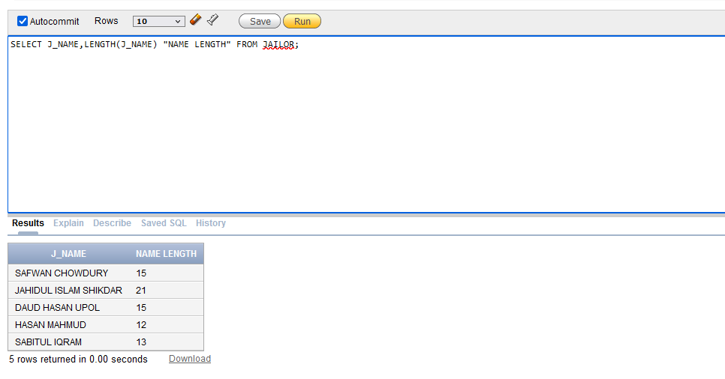

**1 multiple row function query:**

QUESTION:

FIND THE MAXIMUM AND MEAN CRIME OF ALL PRISONERS

SELECT MAX(CRIME_COUNT),ROUND(AVG(CRIME_COUNT)) FROM CRIME;

**1 SINGLE ROW SUB QUERY:**

QUESTION:

SHOW THE PRISONER INFORMATION WHO'S CELL NUMBER IS 301

SELECT * FROM PRISONER WHERE P_ID = (SELECT P_ID FROM CELL WHERE CELL_NUMBER = 301);

**1 MULTI ROW SUB QUERY:**

QUESTION:

SHOW ALL THE PRISONERS WHO HAVE DONE 2 CRIMES

SELECT * FROM PRISONER WHERE P_ID IN (SELECT P_ID FROM CRIME WHERE CRIME_COUNT = 2);

**2 COMPLEX SUB QUERY:**

QUESTION:

SHOW ALL THE VISITOR INFORMATION WHO IS GOING TO VISIT FEMALE PRISONERS WHO IS NOT UNDER REMAND

SELECT * FROM VISITOR WHERE P_ID IN (SELECT P_ID FROM PRISONER WHERE P_ID IN (SELECT P_ID FROM CRIME WHERE REMAND = 'NO') AND GENDER = 'FEMALE');

QUESTION:

SHOW ALL THE PRISONER INFORMATION WHO ARE CHARGED FOR MURDER.

SELECT * FROM PRISONER WHERE P_ID IN (SELECT P_ID FROM CRIME WHERE CASE_ID = (SELECT CASE_ID FROM CASE WHERE CASE_TYPE = 'MURDER'));

**JOINING QUERIES:**

**EQUIJOIN QUERY:**

QUESTION:

SHOW THE INFORMATION OF PRISONER ID, PRISONER NAME, DATE IN, CASE TYPE CRIME COUNT USING EQUIJOIN.

SELECT P.P_ID,P.P_NAME,C.DATE_IN,CASE.CASE_TYPE,C.CRIME_COUNT FROM PRISONER P, CRIME C,CASE WHERE CASE.CASE_ID = C.CASE_ID AND C.P_ID = P.P_ID;

**NON-EQUIJOIN QUERY:**

QUESTION:

SHOW THE PUNISHMENT NAME OF ALL THE PRISONERS USING NON-EQUIJOIN

SELECT P.P_ID,P.P_NAME,PT.PMENT_NAME FROM PUNISHMENT PT, CRIME C, PRISONER P WHERE C.CRIME_COUNT BETWEEN PT.PMENT_LOW AND PT.PMENT_HIGH AND P.P_ID = C.P_ID;

**LEFT OUTER JOIN QUERY:**

QUESTION:

SHOW ALL THE CELL AND PRISONER FROM CELL USING LEFT OUTER JOIN

SELECT C.CELL_NUMBER,P.P_NAME FROM CELL C LEFT OUTER JOIN PRISONER P ON (C.P_ID = P.P_ID) ORDER BY CELL_NUMBER DESC;

**FULL OUTER JOIN QUERY:**

QUESTION:

SHOW ALL INFORMATION OF PRISONER ID ,PRISONER NAME AND CELL NUMBER FROM PRISONER AND CELL.

SELECT P.P_ID,P.P_NAME,C.CELL_NUMBER FROM PRISONER P FULL OUTER JOIN CELL C ON(P.P_ID = C.P_ID);

**SELF JOIN QUERY:**

QUESTION:

SHOW PRISONER ID AND CRIME COUNT WHO HAS SAME NUMBER OF CRIME.

SELECT A.P_ID,A.CRIME_COUNT,B.P_ID,B.CRIME_COUNT FROM CRIME A,CRIME B WHERE A.P_ID <> B.P_ID AND A.CRIME_COUNT = B.CRIME_COUNT AND A.REMAND = B.REMAND;

**VIEW:**

QUESTION:

SHOW PRISONER ID , PRISONER NAME , DATE IN, CASE TYPE , CRIME COUNT BY CREATING A VIEW.

CREATE OR REPLACE VIEW PRISONERVIEW (PRISONER_ID, PRISONER_NAME, DATE_IN, CASE_TYPE,CRIME_COUNT) AS SELECT P.P_ID,P.P_NAME,C.DATE_IN,CASE.CASE_TYPE,C.CRIME_COUNT FROM PRISONER P, CRIME C,CASE WHERE CASE.CASE_ID = C.CASE_ID AND C.P_ID = P.P_ID;

SELECT * FROM PRISONERVIEW;

**SEQUENCE:**

CREATE SEQUENCE CELLSEQUENCE

MINVALUE 321

MAXVALUE 399

START WITH 321

NOCACHE

NOCYCLE

INCREMENT BY 1;

INSERT INTO CELL VALUES(CELLSEQUENCE.NEXTVAL,'TNT',1,NULL);

INSERT INTO CELL VALUES(CELLSEQUENCE.NEXTVAL,'ATOM',1,NULL);

INSERT INTO CELL VALUES(CELLSEQUENCE.NEXTVAL,'GRAMO',1,NULL);

INSERT INTO CELL VALUES(CELLSEQUENCE.NEXTVAL,'KILLJOY',1,NULL);

INSERT INTO CELL VALUES(CELLSEQUENCE.NEXTVAL,'BRIMMER',1,NULL);

INSERT INTO CELL VALUES(CELLSEQUENCE.NEXTVAL,'STONNER',1,NULL);

SELECT * FROM CELL;

**CONCLUSION:**

This project is just a framework with many more potential attachments to it. As this an introductory course of database, our skill level is not good enough to build a more accurate system to manage a huge facility like prison. We think when we will gain more knowledge about advance database, we can apply more tables, security and more complexity added to the system. Suppose we want to add more different kind of sections in the prison with more titled officers, constables, and so on. We can also add solitary unit, isolation unit, medical ward, doctor’s office, entertainment room and more. This prison management system is a unique and diverse system which can be upgraded in many ways and by making it more complex and diverse. In future, we can develop this project with our efficiency.